SIEMPREVIVA

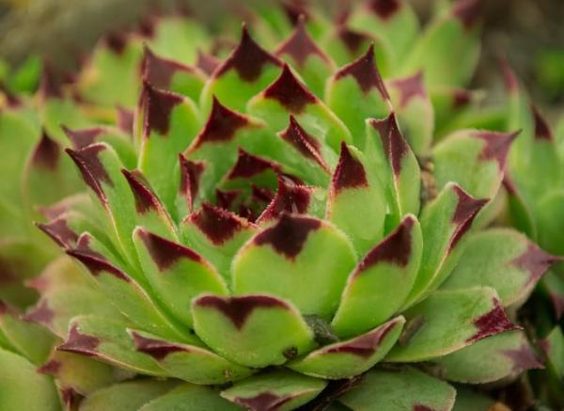

<https://t2.ev.ltmcdn.com/es/posts/2/2/9/siempreviva_sempervivum_2922_16_600.webp>

UÑA DE GATO

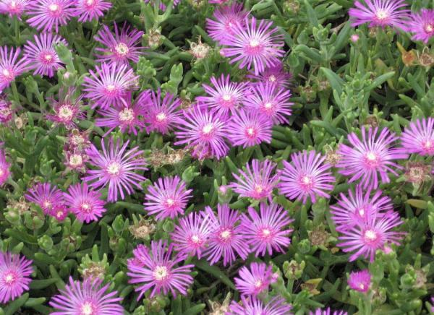

<https://t2.ev.ltmcdn.com/es/posts/2/2/9/una_de_gato_lampranthus_spectabilis_2922_17_600.webp>

PLANTA DE JADE

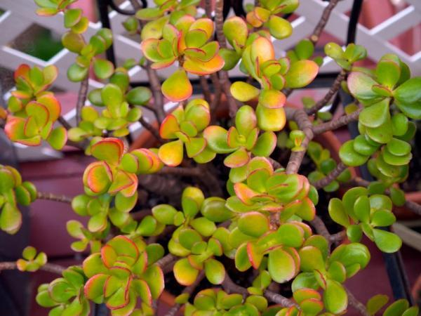

<https://t1.ev.ltmcdn.com/es/posts/2/2/9/planta_de_jade_crassula_ovata_2922_18_600.webp>

OJO DE DRAGON

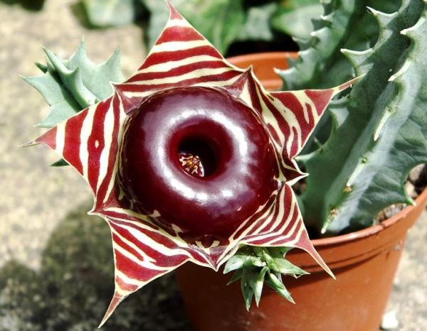

<https://t2.ev.ltmcdn.com/es/posts/2/2/9/ojo_de_dragon_huernia_2922_19_600.webp>

SIGILOSA ARBUSTIVA

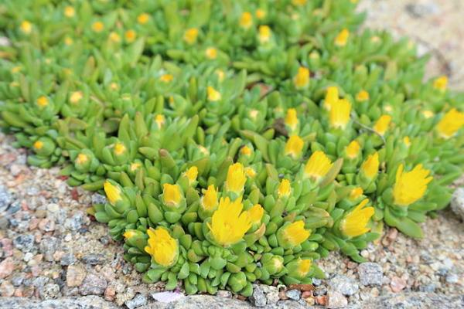

<https://t1.ev.ltmcdn.com/es/posts/2/2/9/sigilosa_arbustiva_delosperma_basuticum_2922_20_600.webp>

CACTUS MAMMILLARIA

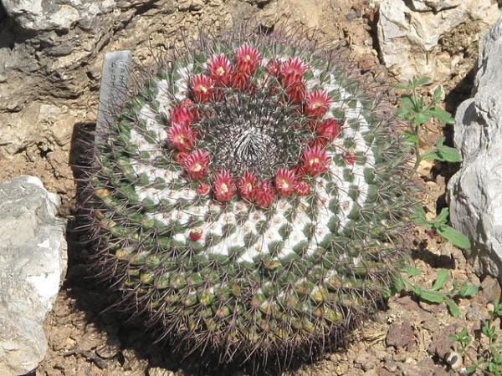

<https://t1.ev.ltmcdn.com/es/posts/2/2/9/cactus_mammillaria_2922_14_600.webp>

CACTUS DE SAN PEDRO

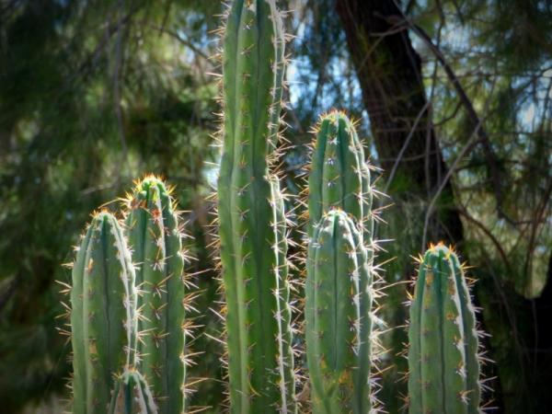

<https://t2.ev.ltmcdn.com/es/posts/2/2/9/cactus_de_san_pedro_echinopsis_pachanoi_2922_13_600.webp>

CACTUS PIEDRA VIVA

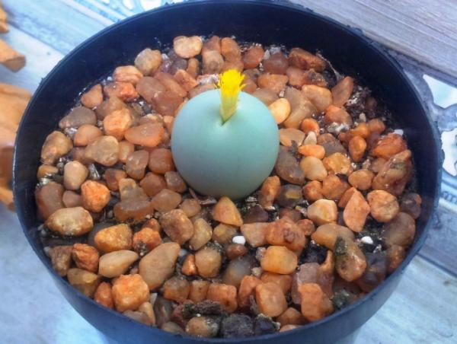

<https://t2.ev.ltmcdn.com/es/posts/2/2/9/cactus_piedra_viva_conophytum_calculus_2922_12_600.webp>

PLANTA ROSARIO

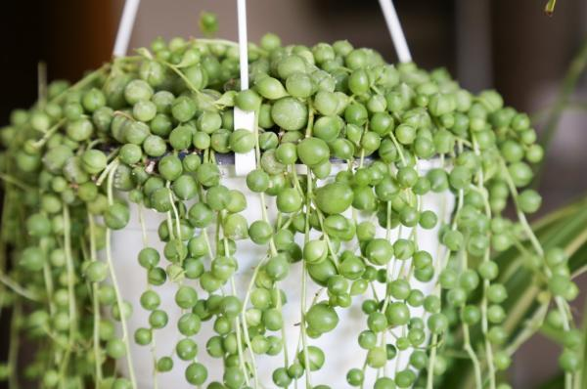

<https://t1.ev.ltmcdn.com/es/posts/2/2/9/planta_rosario_senecio_rowleyanus_2922_11_600.webp>

ALOE VERA

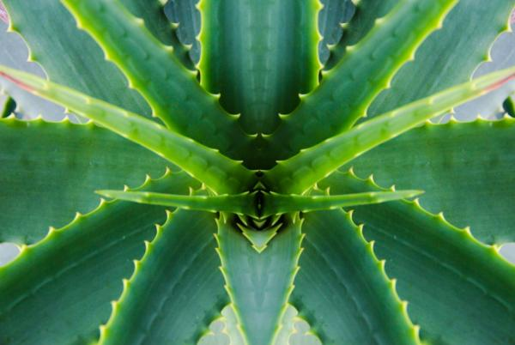

<https://t2.ev.ltmcdn.com/es/posts/2/2/9/aloe_vera_2922_6_600.webp>

ECHEVERIA AGAVOIDES

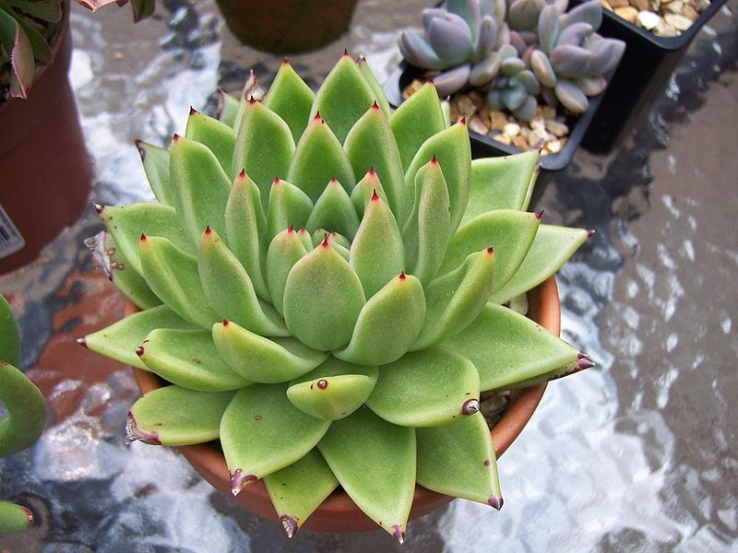

<https://www.jardineriaon.com/wp-content/uploads/2018/11/Echeveria_Agavoides.jpg>

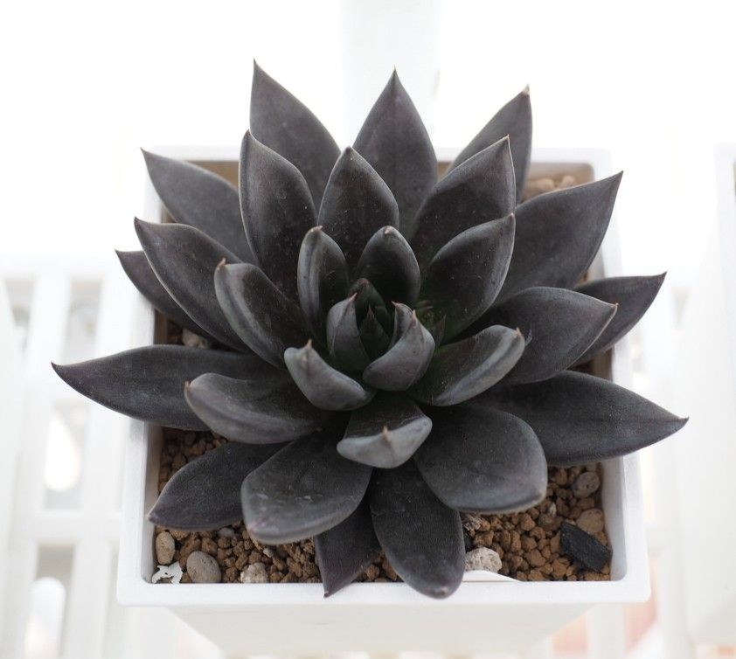BLACK KNIGHT

<https://i.pinimg.com/originals/c1/eb/30/c1eb3071ee2afbcfd820a9360730c939.jpg>

ECHEVERIA SHAVIANA

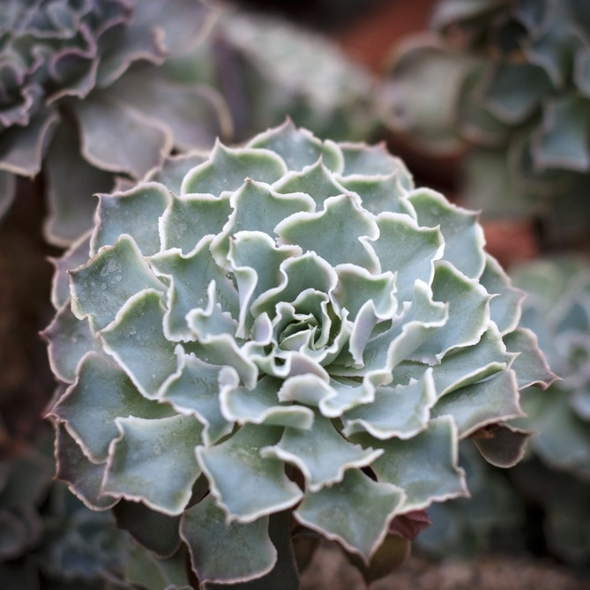

<https://www.picturethisai.com/wiki-image/1080/34E37FFA65A54ADABB9A3CE7CD3DC068.jpeg>

BLACK PRINCE

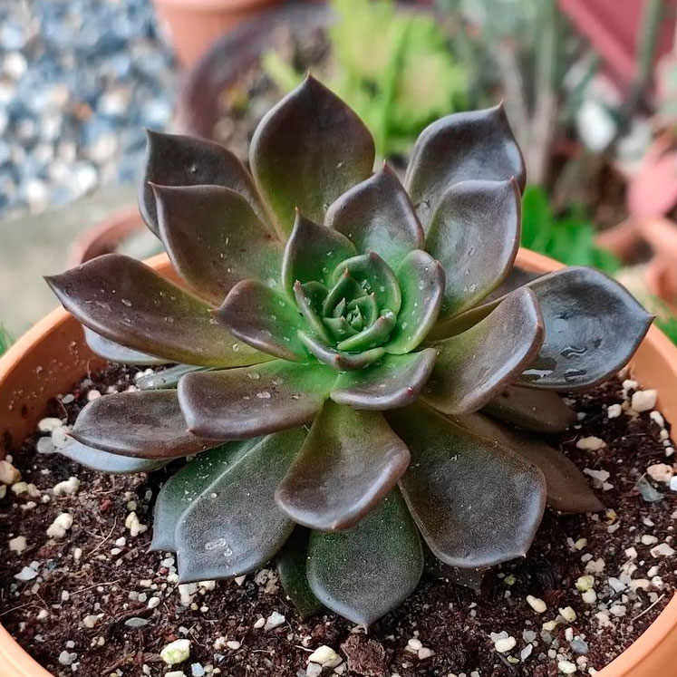  
<https://todoparatuhuerta.com/wp-content/uploads/2022/06/Echeveria-Black-Prince-4.jpg>

ECHEVERIA CHIHUAHENSI

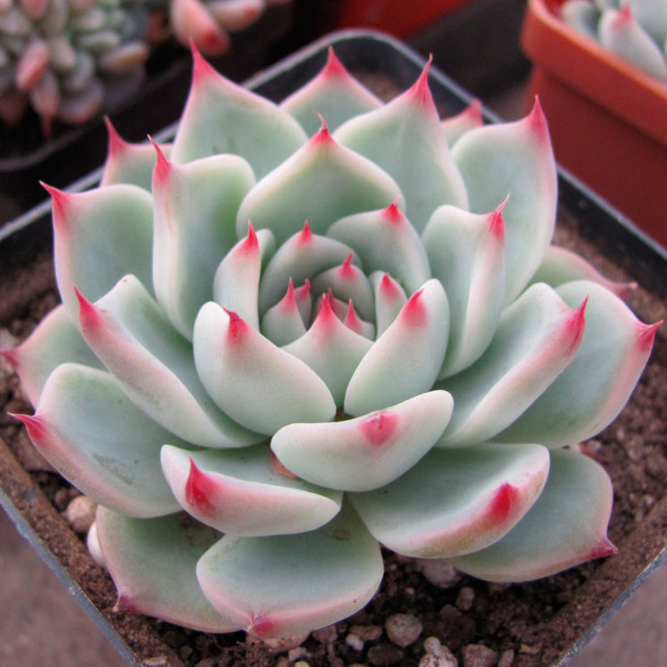

<https://todoparatuhuerta.com/wp-content/uploads/2021/01/Echeveria-chihuahuensis.jpg>

ECHEVERIA CANTE

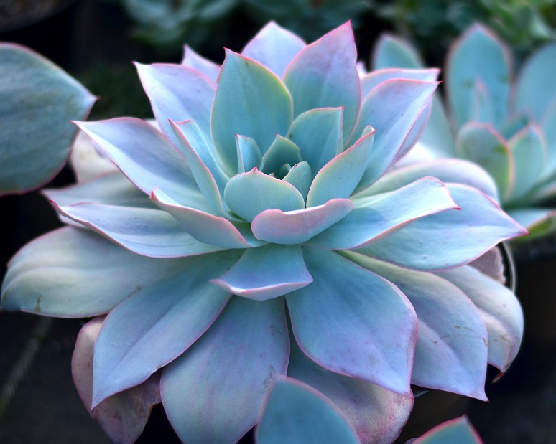

<https://measombras.gt/wp-content/uploads/2022/01/Echeveria-cante.jpg>

ECHEVERIA ELEGANS

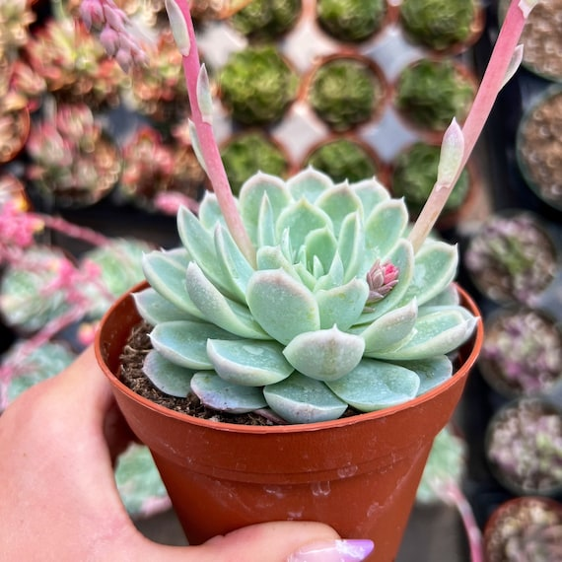

<https://i.etsystatic.com/13687258/r/il/02fe84/3697028534/il_570xN.3697028534_cv9t.jpg>

ECHEVERIA LAUI

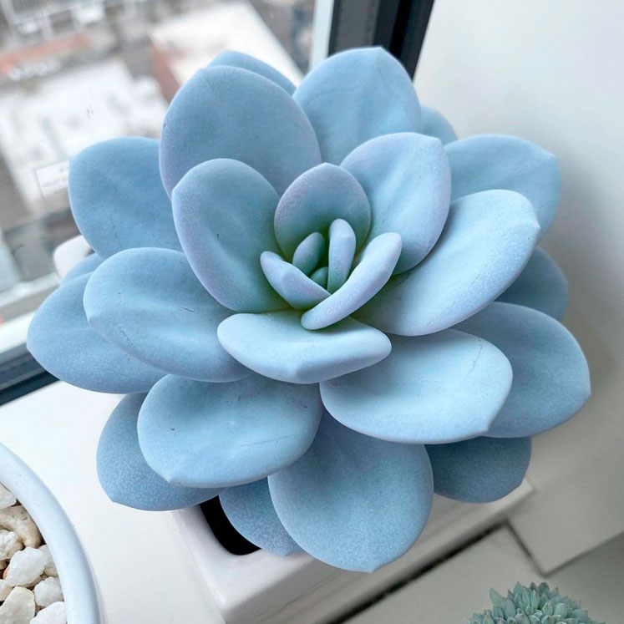

<https://todoparatuhuerta.com/wp-content/uploads/2020/12/Echeveria-Laui-4.jpg>

ECHEVERIA LILACINA

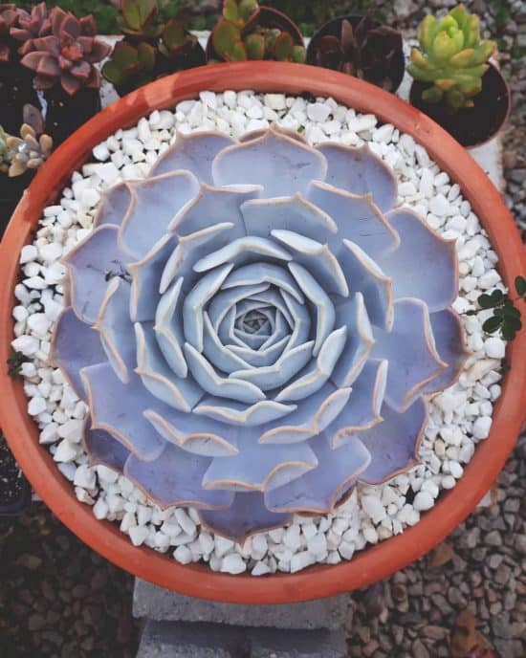

<https://eadn-wc01-3142310.nxedge.io/wp-content/uploads/2020/05/Echeveria-lilacina-e1589797750951.jpg>

ECHEVERIA LOLA

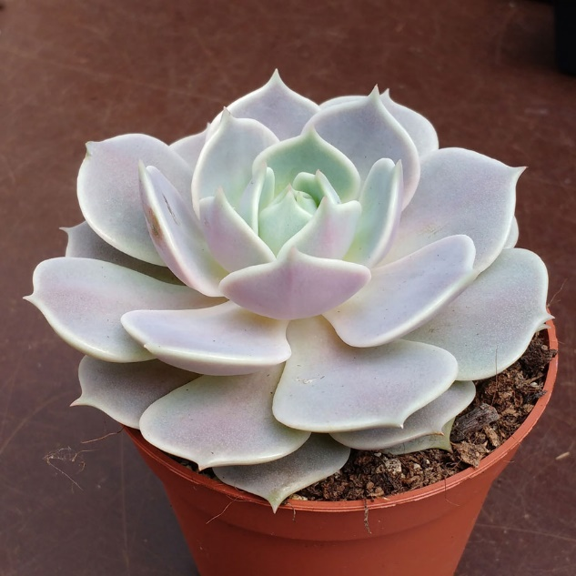

<https://todoparatuhuerta.com/wp-content/uploads/2020/08/echeveria-lola.jpg>

ECHEVERIA PEACOCKII

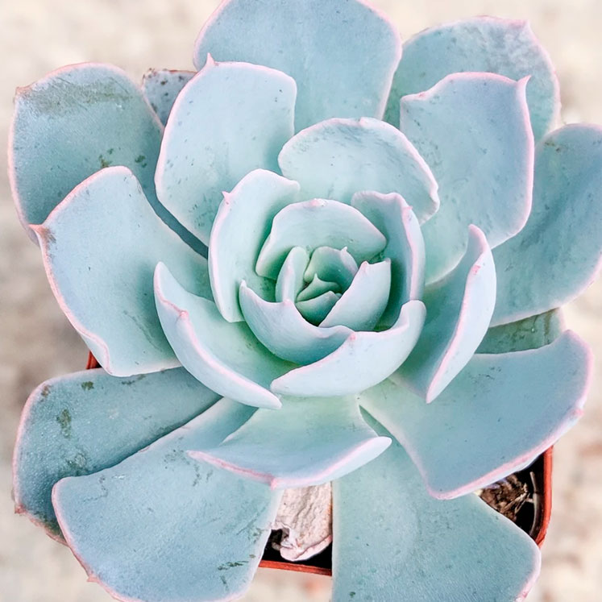

<https://todoparatuhuerta.com/wp-content/uploads/2020/12/Echeveria-desmetiana.jpg>

ECHEVERIA PULVINATA

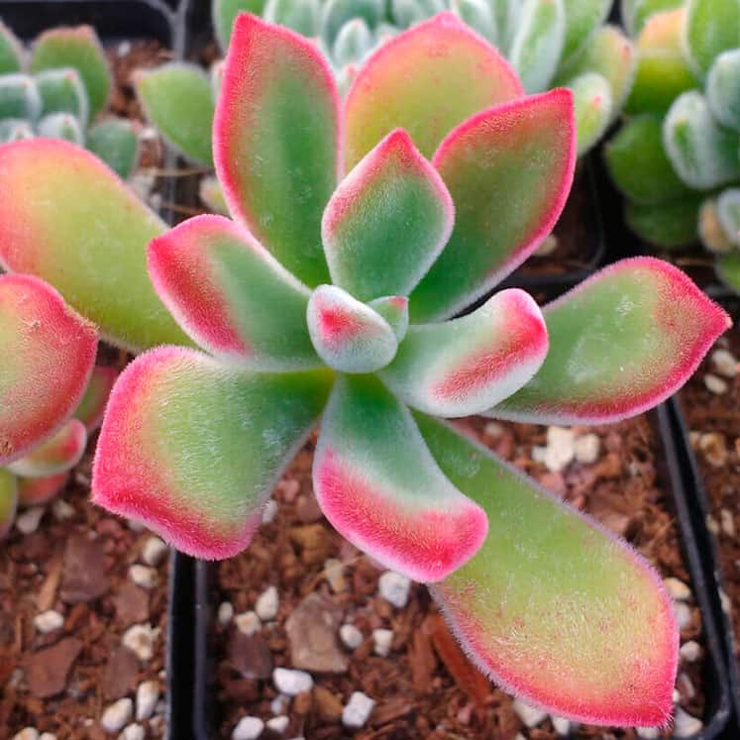

<https://todoparatuhuerta.com/wp-content/uploads/2022/09/Echeveria-pulvinata-Ruby.jpg>

ECHEVERIA SECUNDA

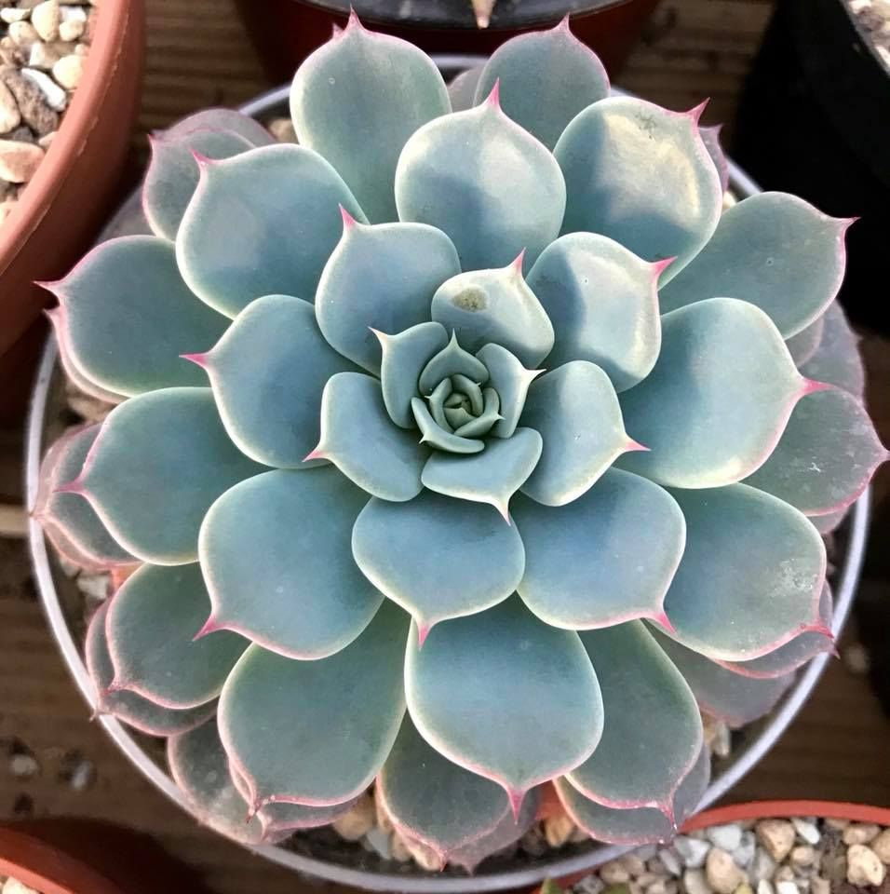

<https://todoparatuhuerta.com/wp-content/uploads/2021/07/Echeveria-Secunda.jpg>

ECHEVERIA SETOSA

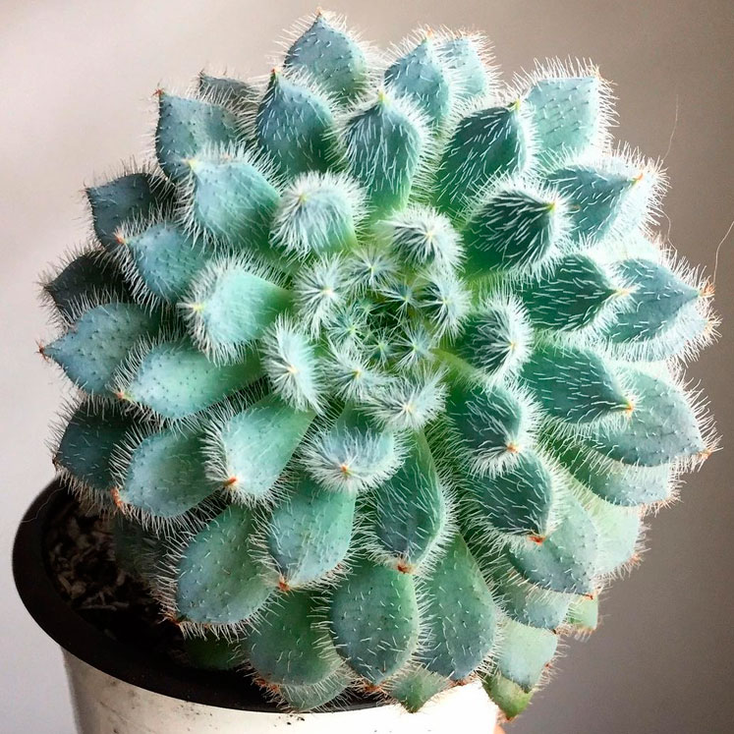

<https://todoparatuhuerta.com/wp-content/uploads/2020/12/Echeveria-Setosa.jpg>

ECHEVERIA SUPERBUM

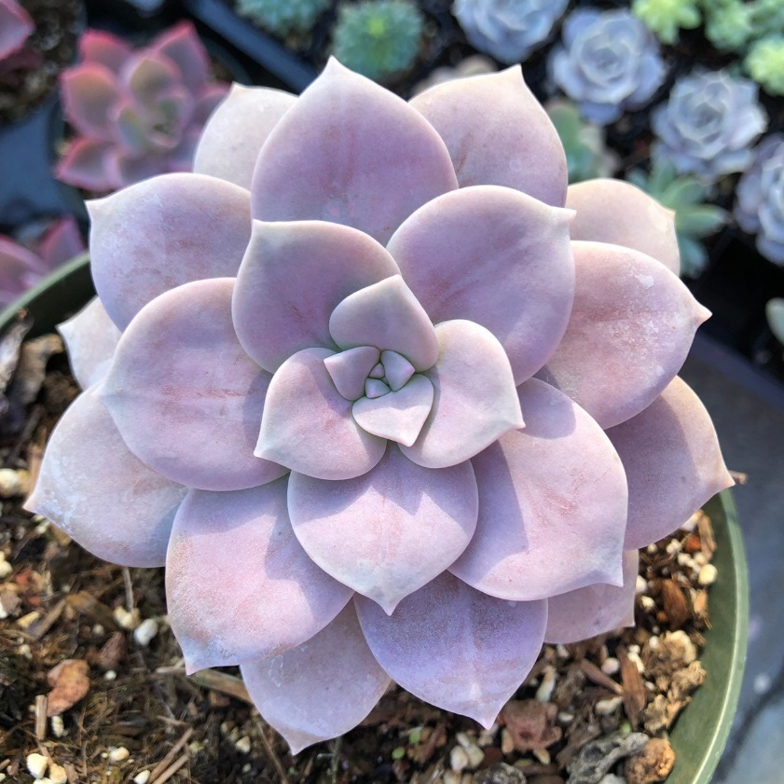

<https://i.etsystatic.com/13687258/r/il/f1fc7b/1783920252/il_fullxfull.1783920252_hpdm.jpg>

PACHYPHYTUM (BABY FINGER)

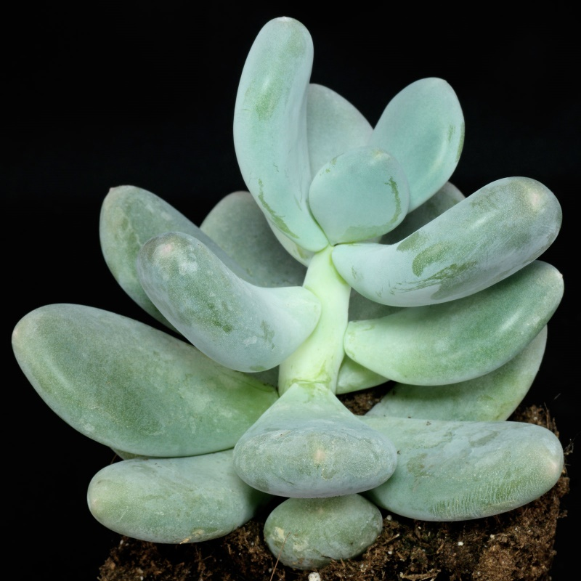

<https://plantasflores.com/cactaceas-suculento/wp-content/uploads/sites/7/2021/11/Pachyphytum-oviferum.jpg>